|  |  |  |  |
| --- | --- | --- | --- |
| **Index** | | | |
| **Sr.no** | **Aim** | **Date** | **Sign** |
| **1.** | **Define a simple services like Converting Rs into Dollar and Call it from different platform like JAVA and .NET** | 11-01-2024 |  |
| **2.** | **Create a Simple SOAP service.** | 17-01-2024 |  |
| **3.** | **Create a Simple REST Service** | 20-01-2024 |  |
| **4.** | **Develop application to consume Google’s search / Google’s Map RESTful Web service** | 23-01-2024 |  |
| **5.** | **Installation and Configuration of virtualization using KVM.** | 25-01-2024 |  |
| **6.** | **Develop application to download image/video from server or upload image/video to server using MTOM techniques** | 29-01-2024 |  |
| **7.** | **Implement FOSS-Cloud Functionality VSI (Virtual Server Infrastructure) Infrastructure as a Service (IaaS), Creating Virtual Machine or Storage** | 03-02-2024 |  |
| **8.** | **I Implementation of Openstack with user and private network creation.** | 22-02-2024 |  |

**Practical-1**

**Define a simple services like Converting Rs into Dollar and Call it from different platform like JAVA and .NET**

Step1: Start NetBeans8.0.2

Step2: go to file -> new project -> java web(select) -> web application

Step3: After that Next and give the project name and finish. Step4: right click on the project name page-> new-> webservice

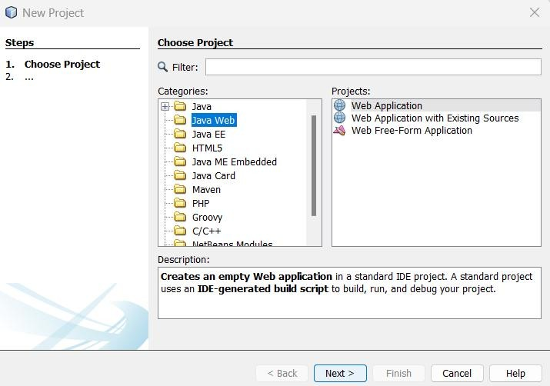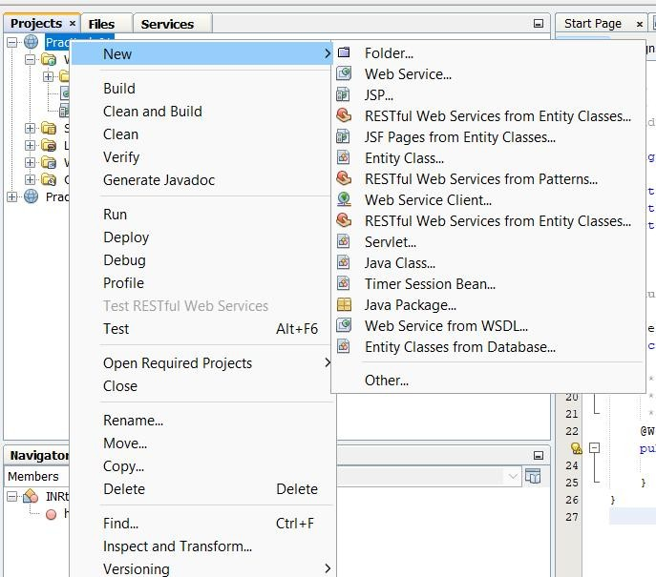

Give the **web service name** and **package name** -> finish

Step5: right click on the web pages ->new -> jsp

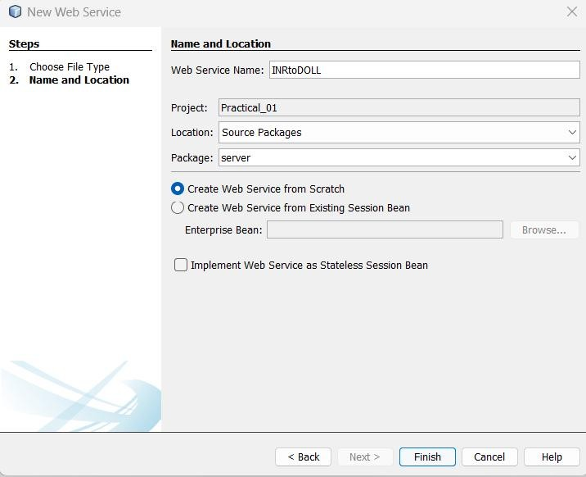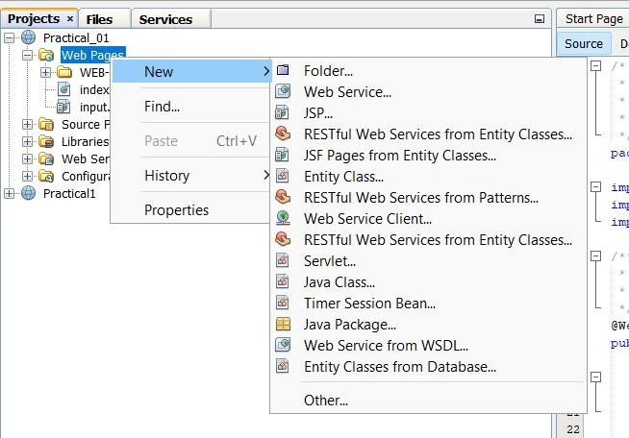

Give the **file name** and finish it.

Step 6: repeat step 5 and create output.jsp.

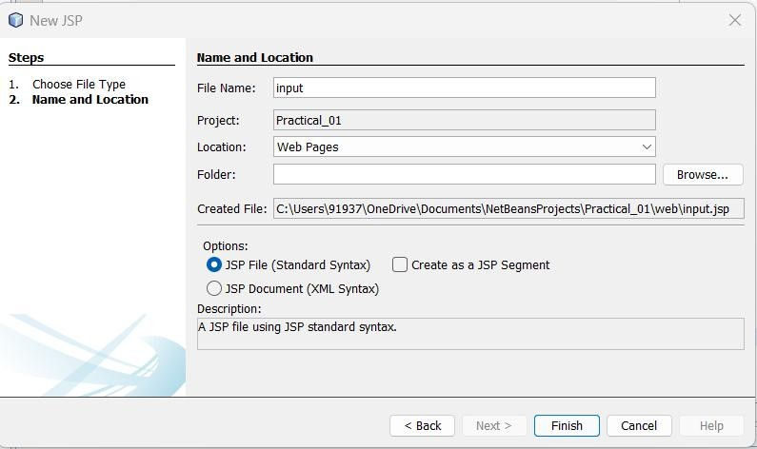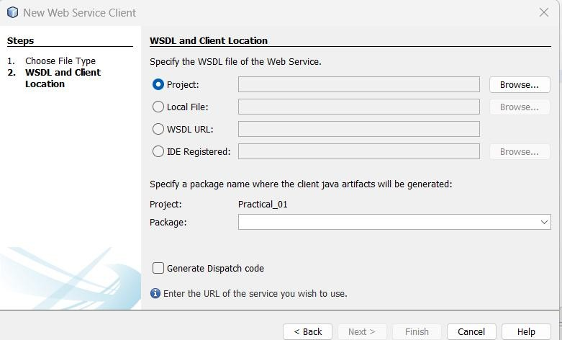

Step 7: right click on the web page -> new -> web service client-> browse (for project name)

Step7: go to java file and right click on the screen -> insert code ->add web service operation

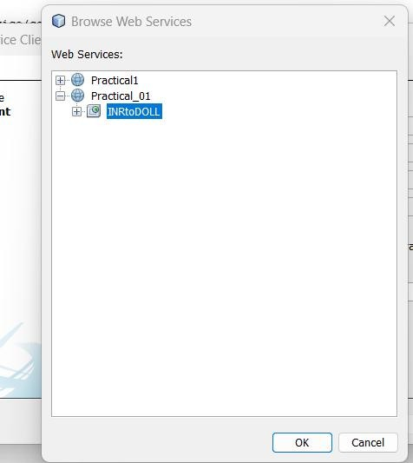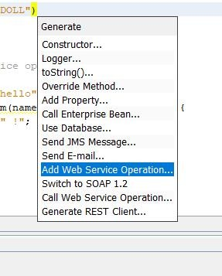

Step8: give the operation name-> click on add button ->give the name of variable and set the data type -

> ok.

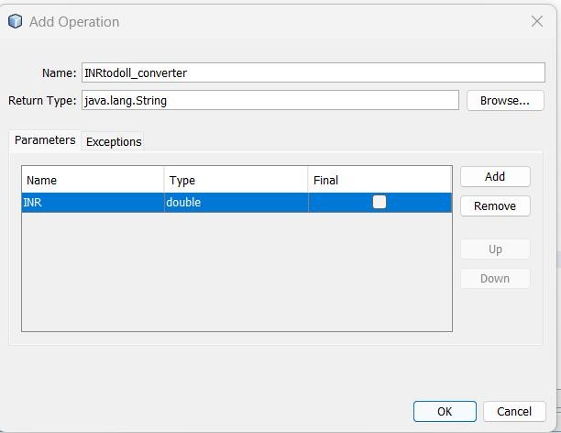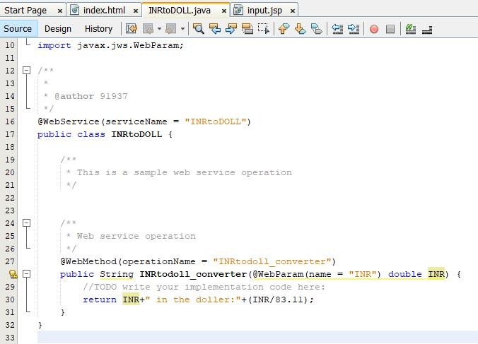

# Client as Java:

Step 9: go to input.jsp

Step 10: open output.jsp . on the left side **web service reference** and select nestedly till the INRtoDOLL pops

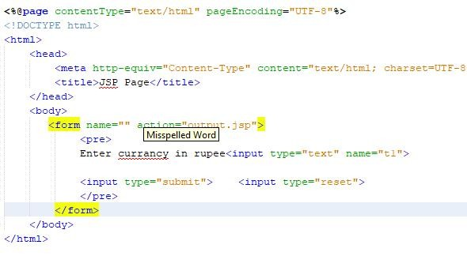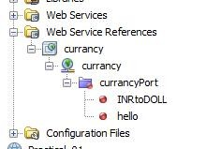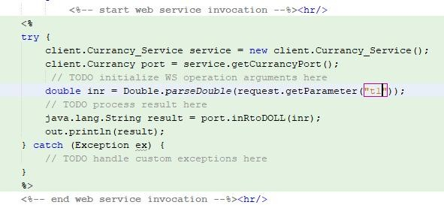

Drag and Drop the INRtoDOLL .

Step 10: right click on the **project name** and **deploy** it.

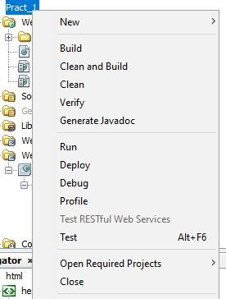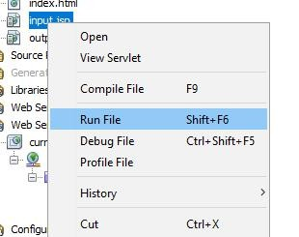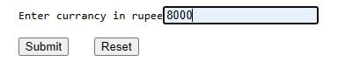

Step 11: right click on the **input.jsp** and select **run file.**

Final output

**Input.jsp**

**Output.jsp**

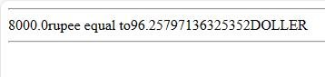

# Client as Python:

Steps:

* 1. Open cmd and Install zeep using command pip install zeep
  2. Open Python IDLE and type following code

### [NOTE: Make sure before running this code your web services is running ]

from zeep import Client

url = '[http://example.com/your-wsdl-url?wsdl'](http://example.com/your-wsdl-url?wsdl%27) client = Client(url)

result = client.service.your_method(param1, param2) print(result)

**Client as .Net:**

### For C#:

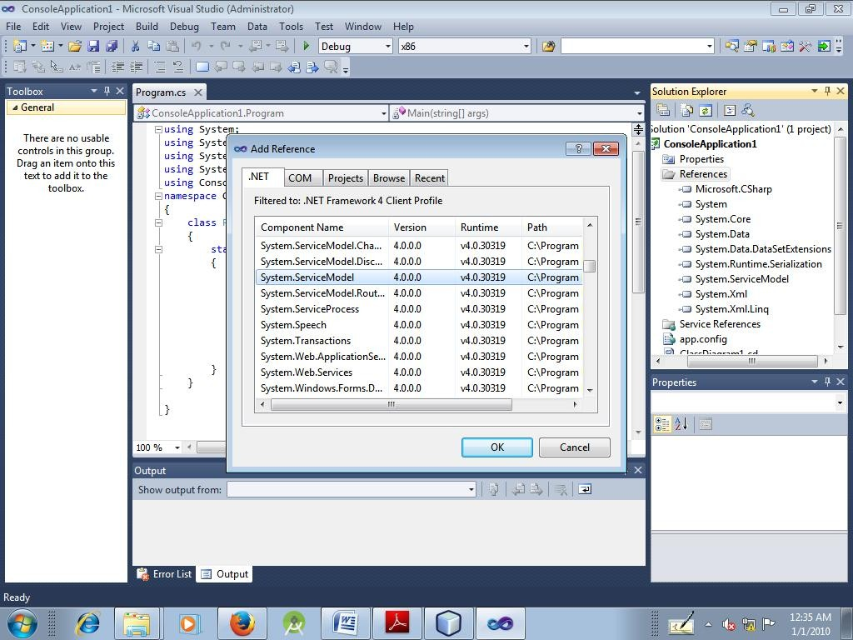

File->new project-> c#-> Console Application->ok

Solution explorer-> ConsoleApplication1 -> Right Click -> Add References -> .Net Tab -> Select System.ServiceModel -> OK

Solution explorer-> ConsoleApplication1 -> Right Click -> Add Service References -

> Copy WSDL Path from browser -> Go ->Expand New Web Service ->OK

### ConsoleApplication1:

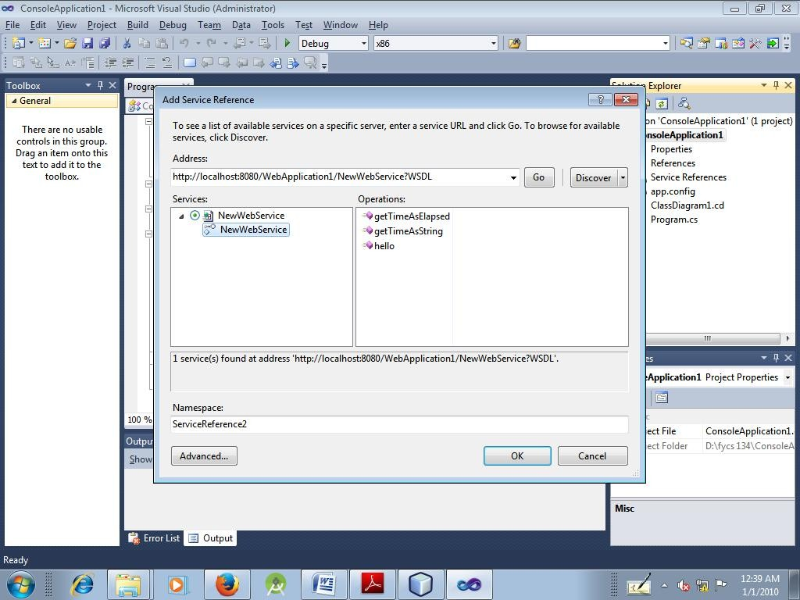

using System;

using System.Collections.Generic; using System.Linq;

using System.Text;

using ConsoleApplication1.ServiceReference1; namespace ConsoleApplication1

{

class Program

{

static void Main(string[] args)

{

NewWebServiceClient sc = new NewWebServiceClient(); Console.WriteLine("TimeAsElapsed" + sc.getTimeAsElapsed()); Console.WriteLine("TimeAsString" + sc.getTimeAsString()); Console.ReadLine();

}

}

}

Run File

**Practical-2**

**Create a Simple SOAP service.**

**To create a Simple Web Service that converts the temperature from Celsius to Fahrenheit and vice v ersa**

**STEPS:**

1. Create a Web Application:

**File > New Project > Java Web > Web Application >** Name: p1 **>**

Add GlassFish Server 4.1 **> Finish >** (you’ll get index.html, delete this file)

1. Create a Web Service in that project:

**Right Click on Project Name > New > Web Service… >**

Name:tempwebservice and Package Name:ty **> OK >** (you’ll get tempwebservice.java file)

1. As we have created our WEB SERVICE(i.e. *tempwebservice*), WE’LL NOW ADD SOME FUNCTIONALITIES (i.e. temperature conversion methods).

So, in the class tempwebservice, add 2 methods by doing:

* 1. **Right Click > Insert Code > Add Web Service Operation…>**

Name: convertFtoC **>**

Return Type: float **>**

Add a Parameter ‘a’ with Type: float **> OK >**

Now add formula in return statement((a-32)*5/9) .

* 1. [**Right Click > Insert Code > Add Web Service Operation…>**](https://e-next.in/)

[Name: convertCtoF **>**](https://e-next.in/)

[Return Type: float **>**](https://e-next.in/)

[Add a Parameter ‘b’ with Type: float **> OK >**](https://e-next.in/)

[Now add formula in return statement((b*9/5)+32) .](https://e-next.in/)

***[CODE(tempwebservice.java):](https://e-next.in/)***

[*package ty;*](https://e-next.in/)

*import javax.jws.WebService; import javax.jws.WebMethod; import javax.jws.WebParam;*

*@WebService(serviceName = "tempwebservice") public class tempwebservice {*

*@WebMethod(operationName = "convertFtoC")*

*public float convertFtoC(@WebParam(name = "a") float a)*

*{ return ((a-32)*5/9);*

*}*

*@WebMethod(operationName = "convertCtoF")*

*public float convertCtoF(@WebParam(name = "b") float b)*

*{ return ((b*9/5)+32);*

*}}*

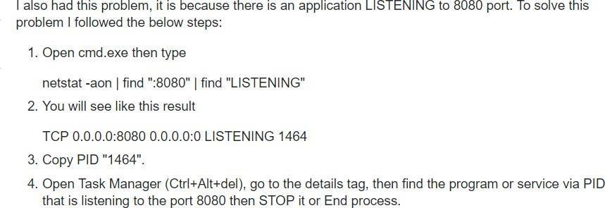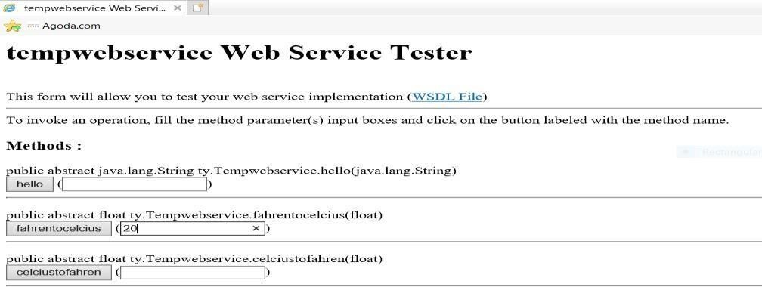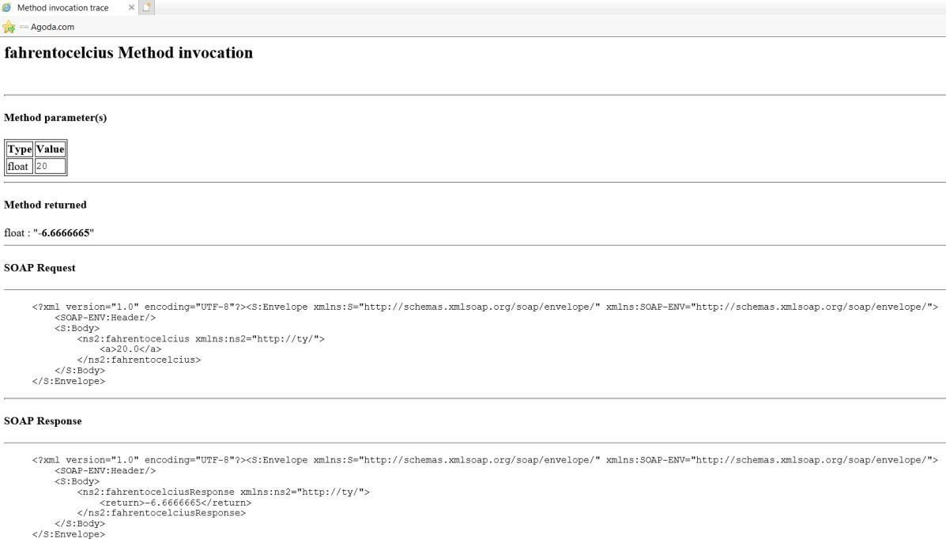

1. Compile(F9) and Deploy(right click on Project Name > Deploy). (If problem in deployment occurs, then do this):
2. Now we’ll test our web service. So navigate to:

**Projects > Project Name > Web Services >** right click on **tempwebservice >**

click **Test Web Service >** (the browser will open). (*tempwebservice* here is a WSDL file)

1. Perform conversions.

* **OUTPUTS:**

1. Now we’ll be using the created Web Service(i.e. *tempwebservice*) by creating our WEB SERVICE CLIENT.

So, **Right Click on Project Name > New > Other > Web Services > Web Service Client… > Browse your Project Name** and **select WSDL file >** Add Package Name: tycs **> Finish.**

(**NOTE THAT** : the package we first created in WEB SERVICE(i.e. *ty*) will now be linked to our created package in CLIENT(i.e. *tycs*). We can also see the **Generated Sources** in the Solution Explorer. We will further use this new package name for the rest.)

1. Now to make front page, we need to create a JSP file.

So, **Right Click on Project Name > New > JSP >** File Name: index **> Finish**.

* Now from the palette, add **HTML Form(**Action:indexaction.jsp**,** Type:text**,** Method:Post**)**
* Inside Form tag, add **Text Input(**Name:txt**)**
* Inside Form tag, add **Button(**Label:Convert**,** Type:submit**,** Name:convert**)**

***CODE(index.jsp):***

*<%@page contentType="text/html" pageEncoding="UTF-8"%>*

*<!DOCTYPE html>*

*<html>*

[*<head>*](https://e-next.in/)

[*<meta http-equiv="Content-Type" content="text/html; charset=UTF-8">*](https://e-next.in/)

[*<title>JSP Page</title>*](https://e-next.in/)

[*</head>*](https://e-next.in/)

[*<body>*](https://e-next.in/)

[*<form action="indexaction.jsp" method="POST">*](https://e-next.in/)[*Enter Temperature:*](https://e-next.in/)

[*<input type="text" name="txt" value="" />*](https://e-next.in/)

*<input type="submit" value="Convert" name="convert" />*

*</form>*

*</body>*

*</html>*

1. Now to create the action behind that, we’ll create another JSP file, with a name thatis declared in the previous JSP file.

So, **Right Click on Project Name > New > JSP >** File Name: indexaction **> Finish**. Then add some <%JSP code%> under body tag.

***CODE(indexaction.jsp):***

*<%@page contentType="text/html"pageEncoding="UTF-8"%>*

*<!DOCTYPE html>*

*<html>*

*<head>*

*<meta http-equiv="Content-Type" content="text/html; charset=UTF-8">*

*<title>JSP Page</title>*

*</head>*

*<body>*

*<%*

*tycs.Tempwebservice_Service obj=new tycs.Tempwebservice_Service(); //obj of service tycs.Tempwebservice port=obj.getTempwebservicePort(); //port for service*

*String val=request.getParameter("txt"); //took the input*

*float temp=Float.parseFloat(val); //parse the input variable to float float result1=port.convertFtoC(temp); //calling the web service method1*

1. **Finish!**

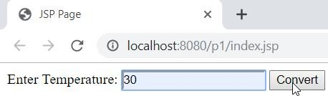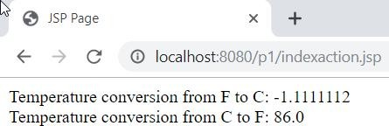

*float result2=port.convertCtoF(temp); //calling the web servicemethod2*

*out.println("Temperature conversion from F to C: "+result1);*

*%>*

*<br/>*

*<%*

*out.println("Temperature conversion from C to F: "+result2);*

[*%>*](https://e-next.in/)

[*</body>*](https://e-next.in/)

[*</html>*](https://e-next.in/)

1. [Now **RUN “index.jsp”** file.](https://e-next.in/)
   * [OUTPUTS:](https://e-next.in/)

### Practical-03

**Create a Simple REST Service**

* Demonstrate CRUD operations with suitable database using RESTful Web service.

1. To start the Java DB Database from NetBeans, perform the following steps. Click Services tab -> Expand Databases node. ->Right-click Java DB icon.

->Select Start Server

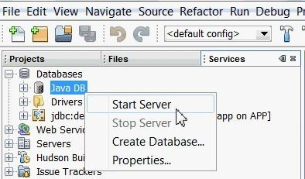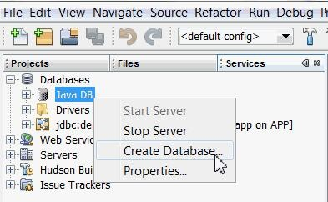

1. To create playerDB database, perform the following steps:

a. Right-click **Java DB** icon, select **Create Database**.

b. Enter the following information for the database:

Database Name: **playerDB** User Name: **john** Password: **john**

Confirm Password:**john**

c. Click OK.

1. To connect to the newly created database playerDB, perform the following steps
   1. Right-click jdbc:derby://localhost:1527/playerDB connection.
   2. Select Connect.
2. Create tables and populate them with data in **playerDB** database.
   1. In NetBeans select File > Open File.
   2. In the file select playersDB.sql.
   3. Click Open. The script automatically opens in the SQL Editor.
3. Examine the contents of the database.
   1. In the Services window, expand

the jdbc:derby://localhost:1527/playerDB connection under the Databases node.

* 1. Right-click the connection and select Refresh.
  2. Expand the john schema. You see the nodes for Tables, Views, and Procedures. d. Expand the Tables node to see the PLAYER and TEAM tables.

e. Right-click the PLAYER table node and select View Data.

### Player server

To create RESTful Web Services, you need a Java Web application project. In the below section you will create a demo Java web project, PlayerServer.

To create new Java Web Project, select File -> New Project -> Java web -> Web Application.

### Generating web service

To generate RESTful Web Services do the following:

1. Right-click the PlayerServer and choose New > Other > Web Services > RESTful Web Services from Database. The New RESTful Web Service wizard opens on the Database Tables panel.
2. In the Database Tables window, select Data Source.

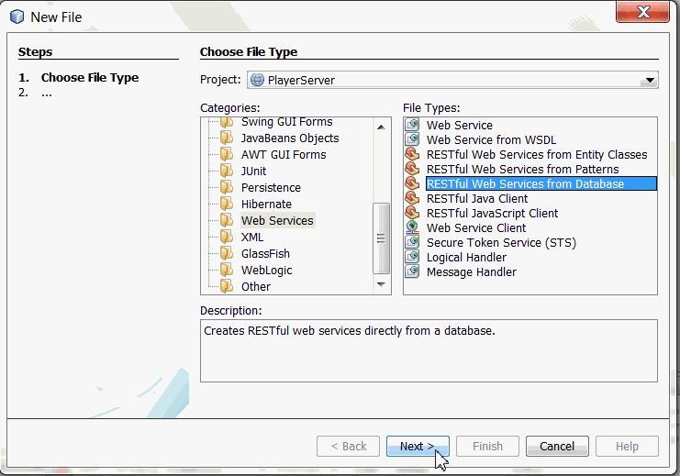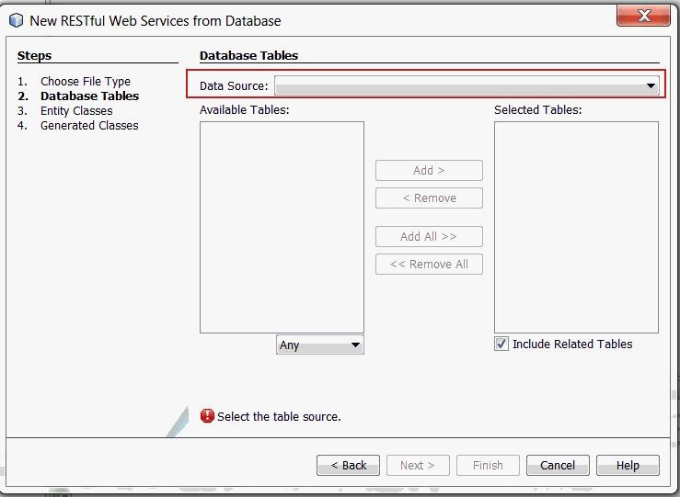

1. Next select "New Data Source" from the Drop-down list.
   1. In the Create Data Source Window, enter the following information:

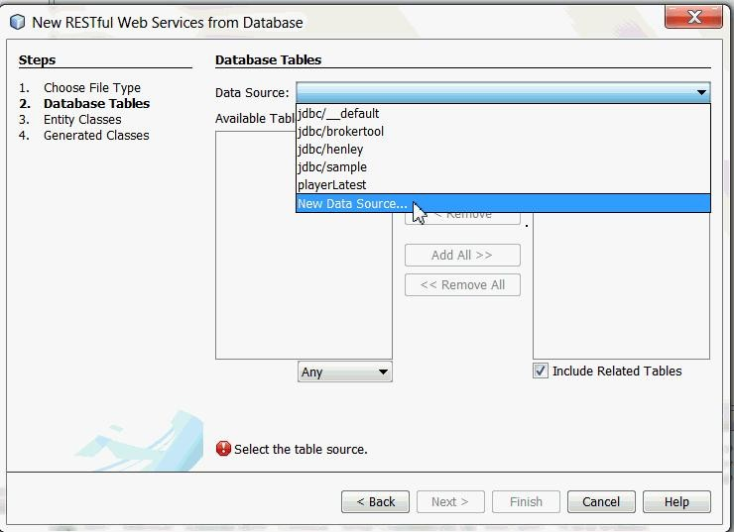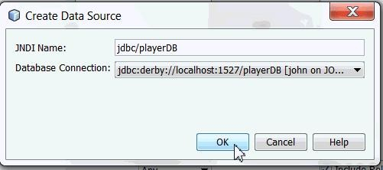

* + - **JNDI name**: jdbc/playerDB
    - **Database connection :** select jdbc:derby://localhost:1527/playerDB[john on JOHN]
  1. Click OK.

The PLAYER and TEAM tables are displayed under the Available Tables column.

* 1. Click **Add All**. The PLAYER and TEAM tables are displayed under the Selected Tables column.
  2. Click Next.

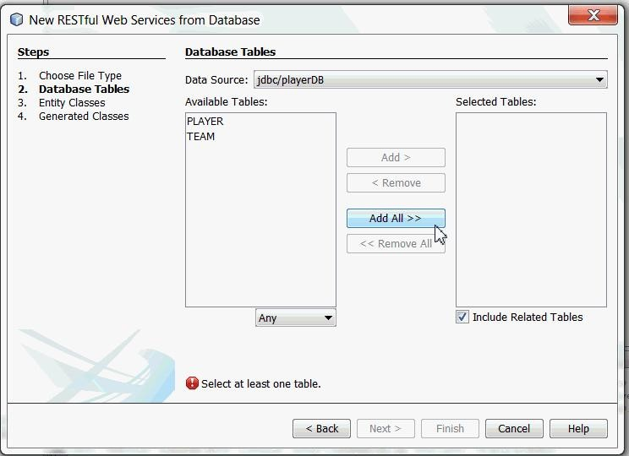

1. In the **Entity Classes** window, complete the following steps:
   1. Enter the package name as com.playerentity.
   2. Click Next.
2. In the **Generated Classes** Window, click Finish with default values.

Test RESTful web Services

1. To Generate Web Services Test client, complete the following steps.
   1. Select **PlayerServer** project.
   2. Right-click and select **Test RESTful Web Services.**
2. Select "Web Test Client in project" and click Browse.
3. a. In the Select Project dialog box, select **PlayerServer** and click OK.

b. **Configure Rest Test Client window** is displayed, click OK.

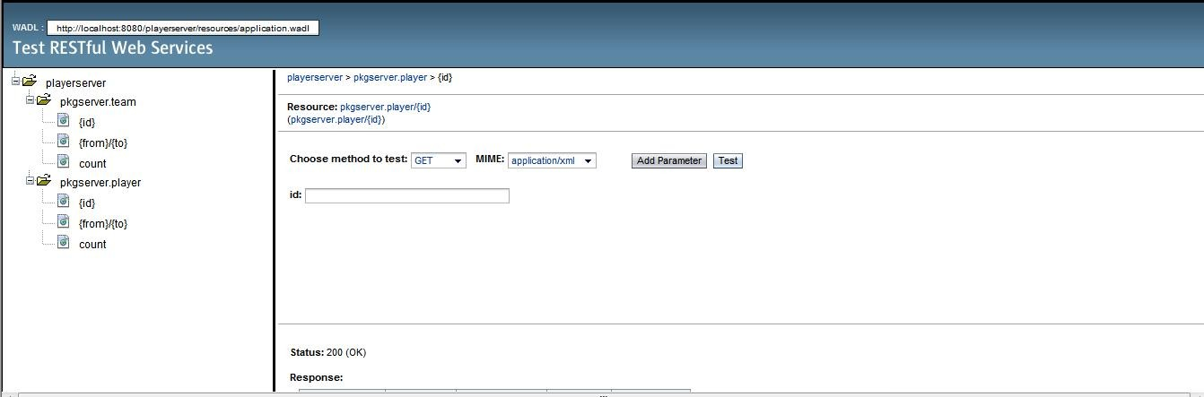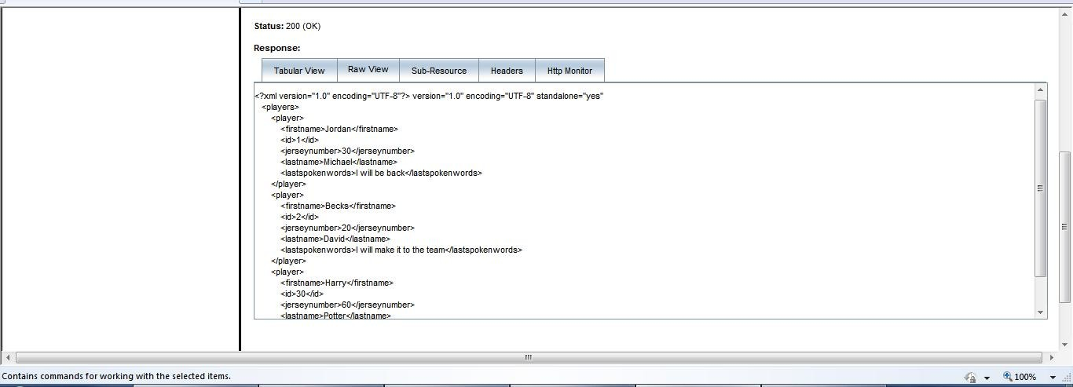

**Player Client**

To create new Java Project, select File > New Project >Playerclient

***Generating Entity Classes from Database***

Implementing CRUD operations on the database, requires creation of Entity Classes to communicate with the database. The following section demonstrates how to create Entity Classes from database.

1. Right-click **PlayerClient** Project and select ***New > Entity Classes From Database***.
2. a. In the Database Tables window, **Database Connection** field

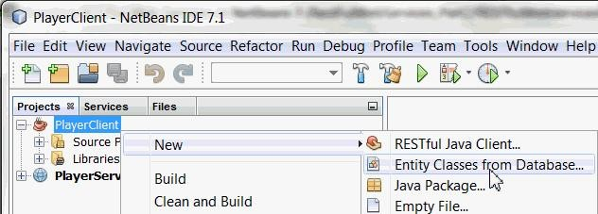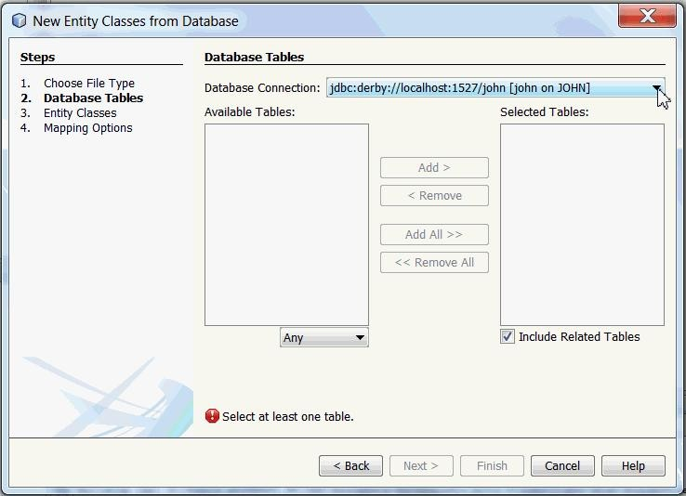

select jdbc:derby://localhost:1527/playerDB[john on JOHN] from the drop-down list.

You see PLAYER and TEAM tables in Available Tables category

b. Click Add All

You see both the tables PLAYER and TEAM in Selected Tables Category.

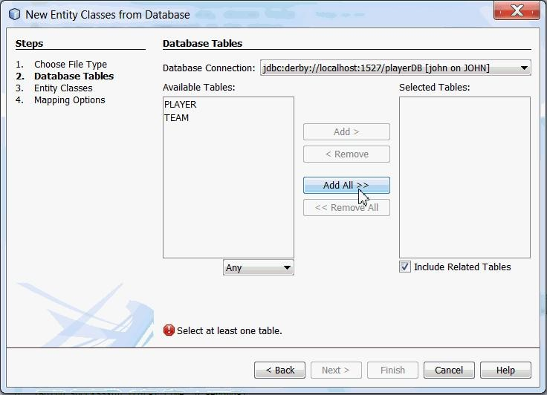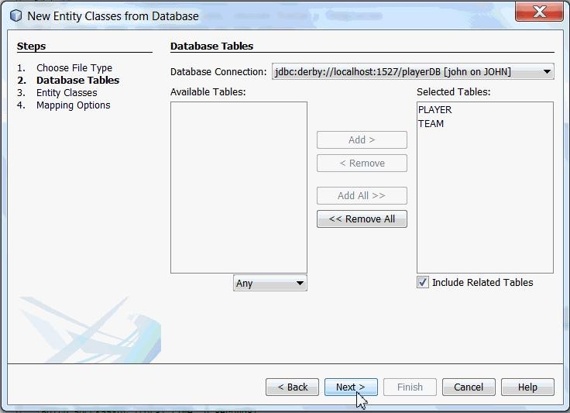

c. Click Next

1. In the Entity classes Window, enter the Package Name as **playerentities** and click Next.

### Create Client

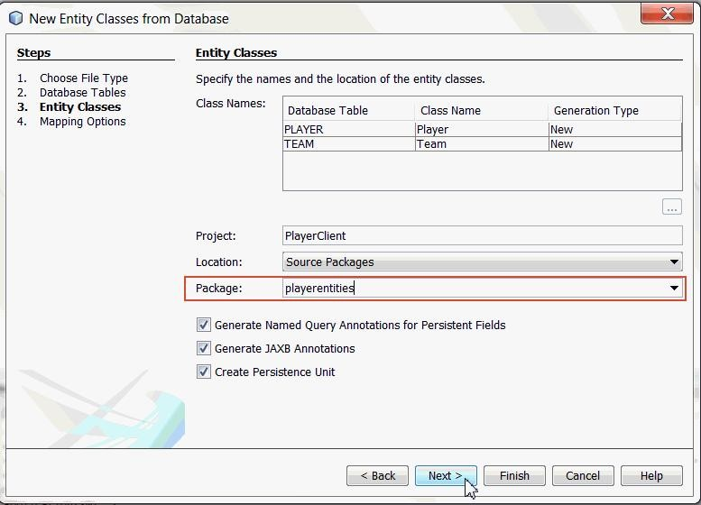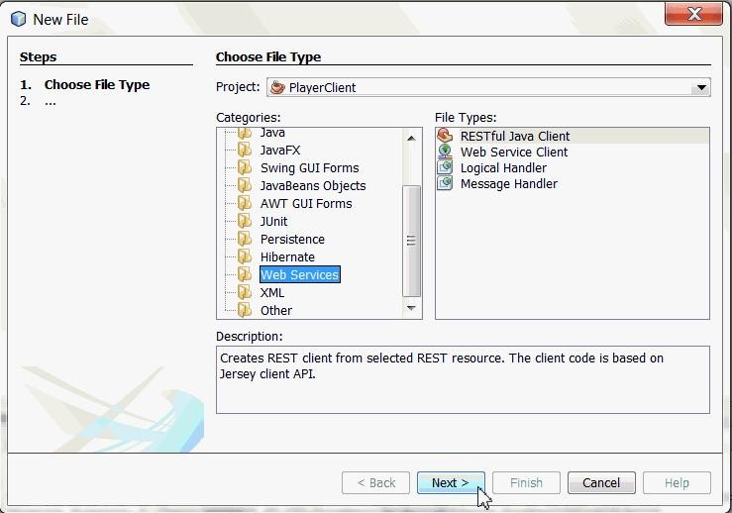

Complete the following steps to create RESTful client in PlayerClient project.

* 1. Right-click the PlayerClient and choose New > Other > Web Services > RESTful Java Client.
  2. Click Next.
     1. a.Enter the following details for the fields in the New Restful Java Client window :
        + Class Name: CreatePlayerJerseyClient
        + Package: playerClient
        + Select the REST resource: From Project and Click Browse.

1. Select PlayerServer.

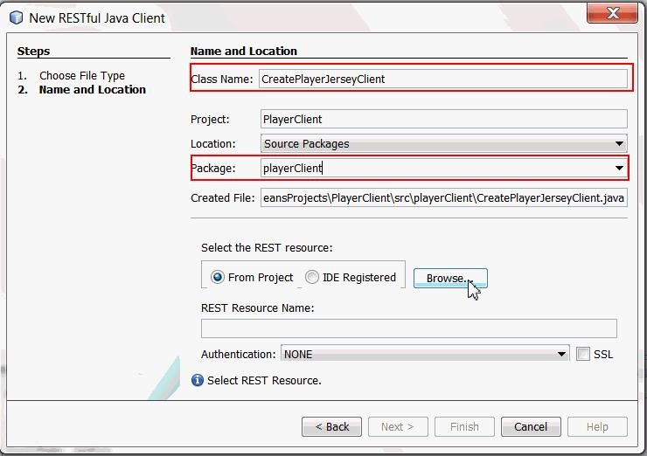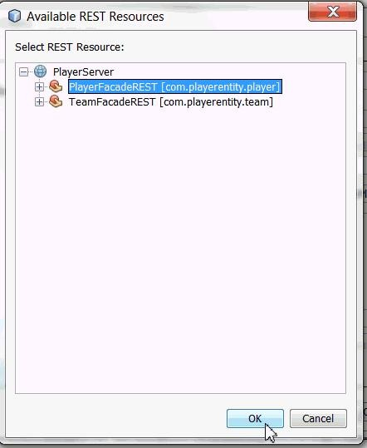

1. Expand the PlayerServer application.
2. Select PlayerFacadeREST[com.playerentity.player].
   * 1. Add the main method.

public static void main(String[]args){

CreateClient client1 = new CreateClient();

ClientResponse response = client1.findAll_XML(ClientResponse.class);

GenericType<List<Player>> genericType = new GenericType<List<Player>>(){}; List<Player> data = new ArrayList<Player>();

data = (response.getEntity(genericType));

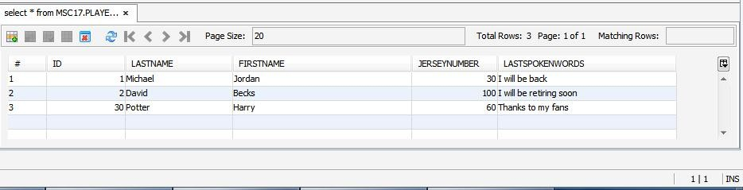

Player p = new Player();

p.setFirstname("Harry"); p.setId(30); p.setJerseynumber(60); p.setLastname("Potter");

p.setLastspokenwords("Thanks to my fans");

client1.create_XML(p);

}

**Read Client**

public static void main(String[]args){

ReadClient client1 = new ReadClient();

ClientResponse response = client1.findAll_XML(ClientResponse.class); GenericType<List<Player>> genericType = new GenericType<List<Player>>(){}; List<Player> data = new ArrayList<Player>();

data = (response.getEntity(genericType)); System.out.println("Retreiving and Displaying Player Details"); for(Player players:data)

System.out.println("FirstName:"+players.getFirstname()); System.out.println("PlayerID:"+players.getId()); System.out.println("JerseyNo:"+players.getJerseynumber());

}

System.out.println("Data Retreived!!");

}

### Delete Client

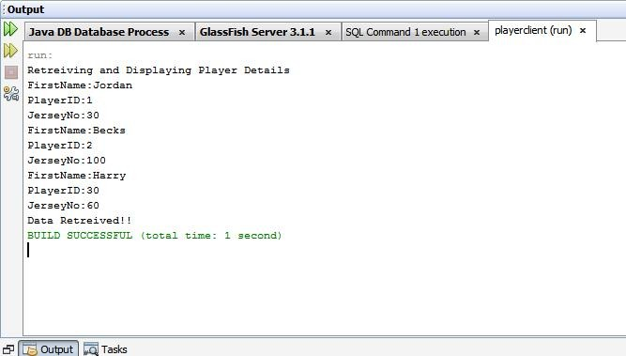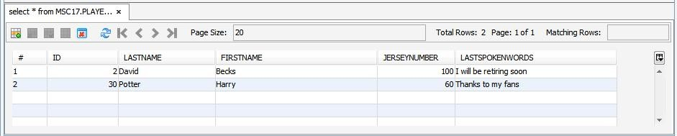

public static void main(String[]args){ DeleteClient client1 = new DeleteClient(); client1.remove("1");

}

### Update Client

public static void main(String[]args){ UpdateClient client1 = new UpdateClient();

ClientResponse response = client1.find_XML(ClientResponse.class, "2"); GenericType<Player>genericType = new GenericType<Player>(){}; Player player = response.getEntity(genericType); System.out.println("First Name: "+player.getFirstname());

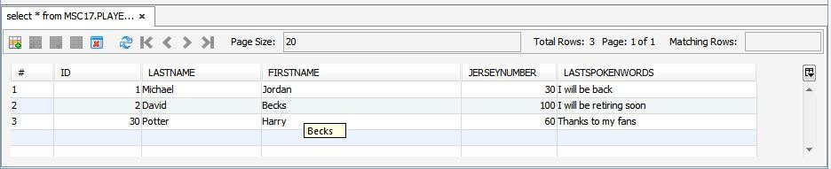

System.out.println("PlayerId: "+player.getId());

System.out.println("JerseyNo: "+player.getJerseynumber()); System.out.println("Last Name: "+player.getLastname()); System.out.println("Last Spoken Words: "+player.getLastspokenwords()); player.setJerseynumber(100);

player.setLastspokenwords("I will be retiring soon");

client1.edit_XML(player);

}

1. To connect to the newly created database playerDB, perform the following steps
   1. Right-click jdbc:derby://localhost:1527/playerDB connection.
   2. Select Connect.
2. Create tables and populate them with data in **playerDB** database.
   1. In NetBeans select File > Open File.
   2. In the file select playersDB.sql.
   3. Click Open. The script automatically opens in the SQL Editor.
3. Examine the contents of the database.
   1. In the Services window, expand

the jdbc:derby://localhost:1527/playerDB connection under the Databases node.

* 1. Right-click the connection and select Refresh.
  2. Expand the john schema. You see the nodes for Tables, Views, and Procedures. d. Expand the Tables node to see the PLAYER and TEAM tables.

e. Right-click the PLAYER table node and select View Data.

### Player server

To create RESTful Web Services, you need a Java Web application project. In the below section you will create a demo Java web project, PlayerServer.

To create new Java Web Project, select File -> New Project -> Java web -> Web Application.

### Generating web service

To generate RESTful Web Services do the following:

1. Right-click the PlayerServer and choose New > Other > Web Services > RESTful Web Services from Database. The New RESTful Web Service wizard opens on the Database Tables panel.
2. In the Database Tables window, select Data Source.



1. Next select "New Data Source" from the Drop-down list.
   1. In the Create Data Source Window, enter the following information:



* + - **JNDI name**: jdbc/playerDB
    - **Database connection :** select jdbc:derby://localhost:1527/playerDB[john on JOHN]
  1. Click OK.

The PLAYER and TEAM tables are displayed under the Available Tables column.

* 1. Click **Add All**. The PLAYER and TEAM tables are displayed under the Selected Tables column.
  2. Click Next.



1. In the **Entity Classes** window, complete the following steps:
   1. Enter the package name as com.playerentity.
   2. Click Next.
2. In the **Generated Classes** Window, click Finish with default values.

Test RESTful web Services

1. To Generate Web Services Test client, complete the following steps.
   1. Select **PlayerServer** project.
   2. Right-click and select **Test RESTful Web Services.**
2. Select "Web Test Client in project" and click Browse.
3. a. In the Select Project dialog box, select **PlayerServer** and click OK.

b. **Configure Rest Test Client window** is displayed, click OK.



**Player Client**

To create new Java Project, select File > New Project >Playerclient

***Generating Entity Classes from Database***

Implementing CRUD operations on the database, requires creation of Entity Classes to communicate with the database. The following section demonstrates how to create Entity Classes from database.

1. Right-click **PlayerClient** Project and select ***New > Entity Classes From Database***.
2. a. In the Database Tables window, **Database Connection** field



select jdbc:derby://localhost:1527/playerDB[john on JOHN] from the drop-down list.

You see PLAYER and TEAM tables in Available Tables category

b. Click Add All

You see both the tables PLAYER and TEAM in Selected Tables Category.



c. Click Next

1. In the Entity classes Window, enter the Package Name as **playerentities** and click Next.

### Create Client



Complete the following steps to create RESTful client in PlayerClient project.

* 1. Right-click the PlayerClient and choose New > Other > Web Services > RESTful Java Client.
  2. Click Next.
     1. a.Enter the following details for the fields in the New Restful Java Client window :
        + Class Name: CreatePlayerJerseyClient
        + Package: playerClient
        + Select the REST resource: From Project and Click Browse.

1. Select PlayerServer.



1. Expand the PlayerServer application.
2. Select PlayerFacadeREST[com.playerentity.player].
   * 1. Add the main method.

public static void main(String[]args){

CreateClient client1 = new CreateClient();

ClientResponse response = client1.findAll_XML(ClientResponse.class);

GenericType<List<Player>> genericType = new GenericType<List<Player>>(){}; List<Player> data = new ArrayList<Player>();

data = (response.getEntity(genericType));



Player p = new Player();

p.setFirstname("Harry"); p.setId(30); p.setJerseynumber(60); p.setLastname("Potter");

p.setLastspokenwords("Thanks to my fans");

client1.create_XML(p);

}

**Read Client**

public static void main(String[]args){

ReadClient client1 = new ReadClient();

ClientResponse response = client1.findAll_XML(ClientResponse.class); GenericType<List<Player>> genericType = new GenericType<List<Player>>(){}; List<Player> data = new ArrayList<Player>();

data = (response.getEntity(genericType)); System.out.println("Retreiving and Displaying Player Details");

System.out.println("FirstName:"+players.getFirstname()); System.out.println("PlayerID:"+players.getId()); System.out.println("JerseyNo:"+players.getJerseynumber());

}

System.out.println("Data Retreived!!");

}

### Delete Client



public static void main(String[]args){ DeleteClient client1 = new DeleteClient(); client1.remove("1");

}

### Update Client

public static void main(String[]args){ UpdateClient client1 = new UpdateClient();

ClientResponse response = client1.find_XML(ClientResponse.class, "2"); GenericType<Player>genericType = new GenericType<Player>(){}; Player player = response.getEntity(genericType); System.out.println("First Name: "+player.getFirstname());



System.out.println("PlayerId: "+player.getId());

System.out.println("JerseyNo: "+player.getJerseynumber()); System.out.println("Last Name: "+player.getLastname()); System.out.println("Last Spoken Words: "+player.getLastspokenwords()); player.setJerseynumber(100);

player.setLastspokenwords("I will be retiring soon");

client1.edit_XML(player);

}

# practical-4

**Develop application to consume Google’s search / Google’s Map RESTful Web service**

* Develop application to consume Google’s search / Google’s Map RESTful Web service.

1. First of all we need to create an Java Web Application with any name, let it be GoogleMap here using Netbeans IDE.
2. The code inside the input.jsp will be similar to this input.jsp Input.jsp

<%@page contentType="text/html" pageEncoding="UTF-8"%>

<!DOCTYPE html>

<html>

<head>

<meta http-equiv="Content-Type" content="text/html; charset=UTF-8">

<title>JSP Page</title>

</head>

<body>

<form action="index.jsp">

<pre>

Enter latitude:<input type="text" name="t1" /> Enter longitude:<input type="text" name="t2" />

<input type="submit" value="Show" />

</pre>

</form>

</body>

</html>

1. Before running the application we need the Google API key. The steps are shown here:

* Visit Google APIs Console (https://console.developers.google.com, you have to login with your Google account).

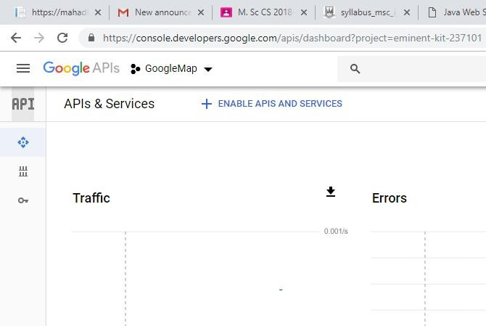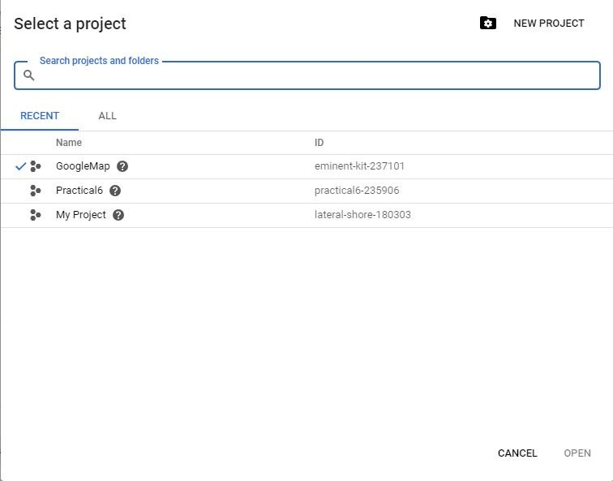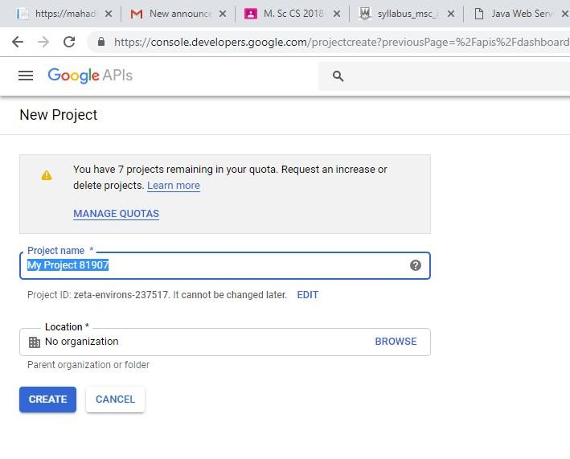

* Create a new API Project.
* Enter the name to your project.
* Enable the Google Maps API V3.

1. Create another file index.jsp

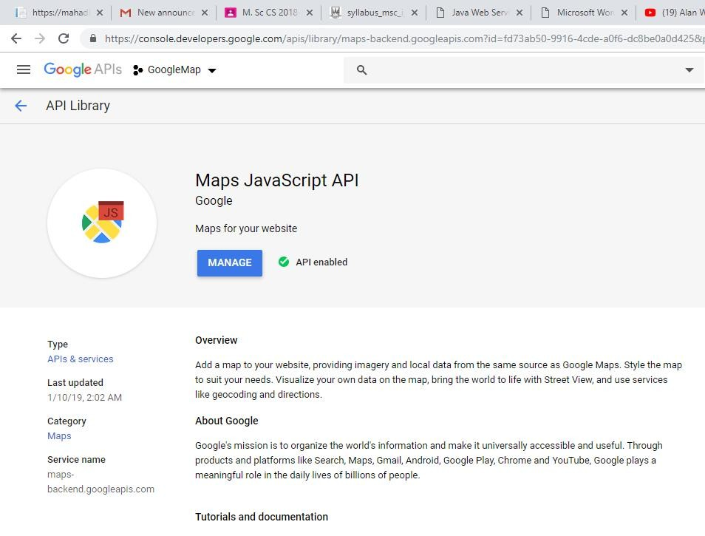

## Index.jsp

<%@page contentType="text/html" pageEncoding="UTF-8"%>

<!DOCTYPE html>

<html>

<head>

<style>

#map {

height: 400px; width: 100%;

}

</style>

</head>

<body>

<%

double lati=Double.parseDouble(request.getParameter("t1")); double longi=Double.parseDouble(request.getParameter("t2"));

%>

<h3> Google Maps </h3>

<div id="map"></div>

<script lang="javascript"> function initMap() {

var info={lat: <%=lati%>, lng: <%=longi%>};

var map = new google.maps.Map(document.getElementById('map'),

{

zoom: 4, center: info

});

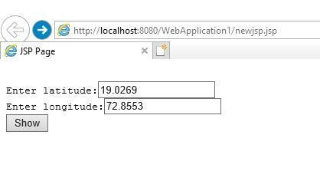

var marker = new google.maps.Marker({

position: info, map: map

});

}

</script>

<script async defer

src="put your key here">

</script>

</body>

</html>

**Output :-**

# practical-5

**Installation and Configuration of virtualization using KVM.**

1. **Aim:** Installation and Configuration of virtualization using KVM
2. **Objectives:** From this experiment, the student will be able to,

* Understand the concepts of virtualization.
* Understand KVM architecture and its configuration.

1. **Outcomes:** The learner will be able**,**

* To analyze user models and develop user centric interfaces
* To analyze the local and global impact of computing on individuals, organizations, and society.
* To engage in life-long learning development and higher studies.
* To understand, identify, analyze and design the problem, implement and validate the solution including both hardware and software.

1. **Hardware / Software Required:** Ubuntu operating system, open source software KVM, Internet.
2. **Theory:**

Virtualization is software that separates physical infrastructures to create various dedicated resources. It is the fundamental technology that powers cloud computing.

The technology behind virtualization is known as a virtual machine monitor (VMM) or virtual manager, which separates compute environments from the actual physical infrastructure.

Virtualization makes servers, workstations, storage and other systems independent of the physical hardware layer. This is done by installing a Hypervisor on top of the hardware layer, where the systems are then installed.

There are three areas of IT where virtualization is making headroads, network virtualization, storage virtualization and server virtualization:

• Network virtualization is a method of combining the available resources in a network by splitting up the available bandwidth into channels, each of which is independent from the others, and each of which can be assigned (or reassigned) to a particular server or device in real time. The idea is that virtualization disguises the true complexity of the network by separating it into manageable parts, much like your partitioned hard drive makes it easier to manage your files.

• Storage virtualization is the pooling of physical storage from multiple network storage devices into what appears to be a single storage device that is managed from a central console. Storage virtualization is commonly used in storage area networks (SANs).

• Server virtualization is the masking of server resources (including the number and identity of individual physical servers, processors, and operating systems) from server users. The intention is to spare the user from having to understand and manage complicated details of server resources while increasing resource sharing and utilization and maintaining the capacity to expand later.

Virtualization can be viewed as part of an overall trend in enterprise IT that includes autonomic computing, a scenario in which the IT environment will be able to manage itself based on perceived activity, and utility computing, in which computer processing power is seen as a utility that clients can pay for only as needed. The usual goal of virtualization is to centralize administrative tasks while improving scalability and work loads.

1. **Procedure:**

Installation Steps :

1. #sudo grep -c "svm\|vmx" /proc/cpuinfo

2. #sudo apt-get install qemu-kvm libvirt-bin bridge-utils virt-manager

3. #sudoadduserrait

#sudoadduserraitlibvirtd

After running this command, log out and log back in as rait

4. Run following command after logging back in as rait and you should see an empty list of virtual machines. This indicates that everything is working correctly.

#virsh -c qemu:///system list

5. Open Virtual Machine Manager application and Create Virtual Machine

#virt-manager

1. **Result:**

_____________________________SNAPSHOTS____________________________

Step 1 : #sudo grep -c "svm\|vmx" /proc/cpuinfo

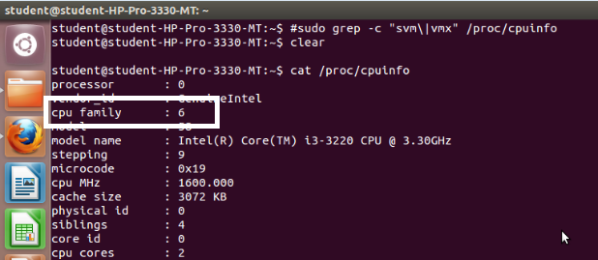

Step 2 : #sudo apt-get install qemu-kvm libvirt-bin bridge-utils virt-manager

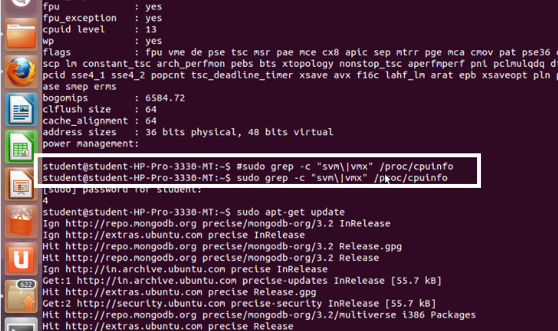

Step 3 : #sudoadduserrait

After running this command, log out and log back in as rait

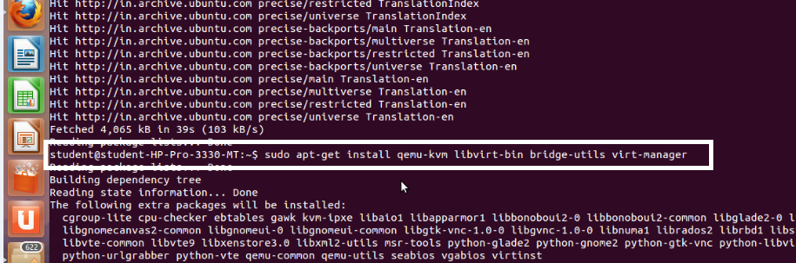

Step 4 : #sudoadduserraitlibvirtd

After running this command, log out and log back in as rait

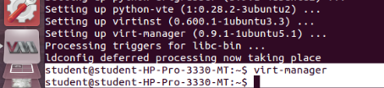

Step 5 : Open Virtual Machine Manager application and Create Virtual Machine

#virt-manager as shown below

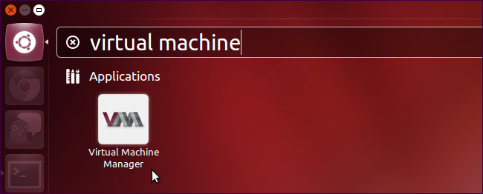

Step 6 : Create a new virtual machine as shown below

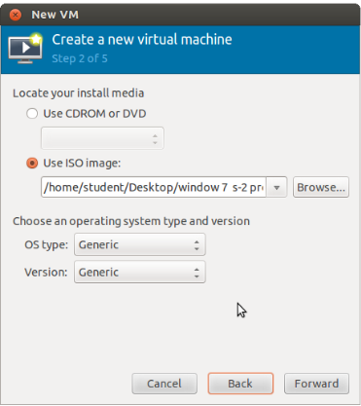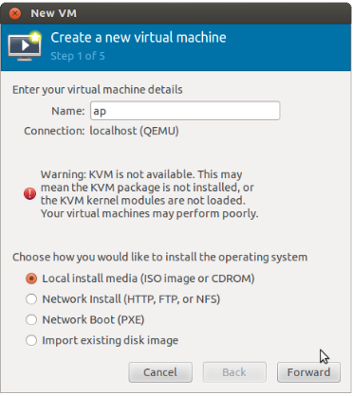

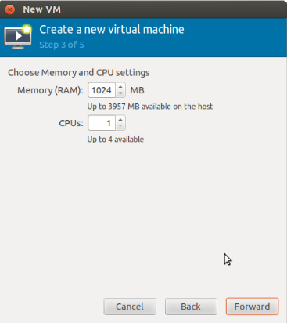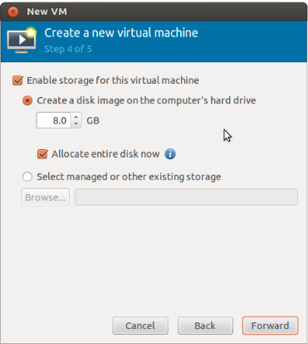

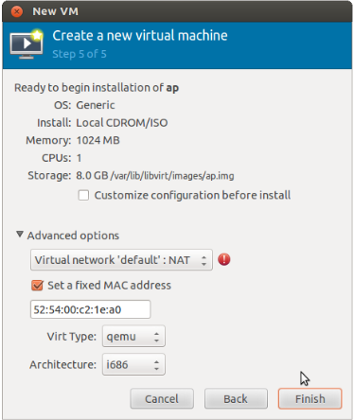

Step 7 : Install windows operating system on virtual machine

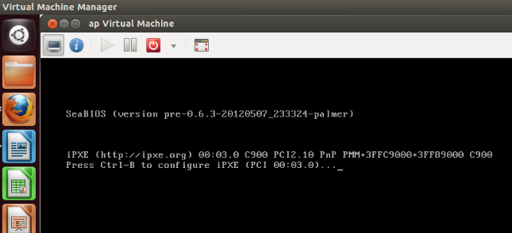

Step 8: Installation of windows on virtual machine

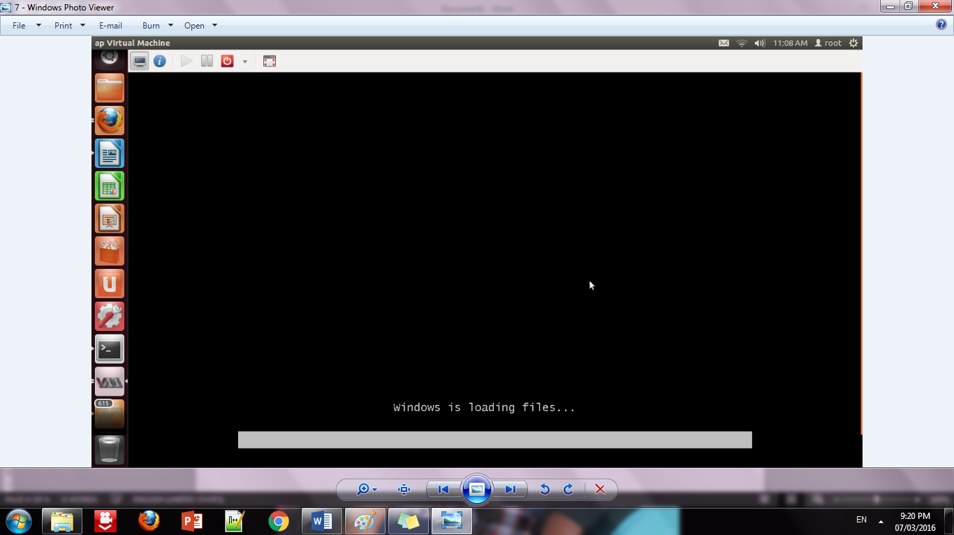

Step 9: Installation of windows 7 on virtual machine

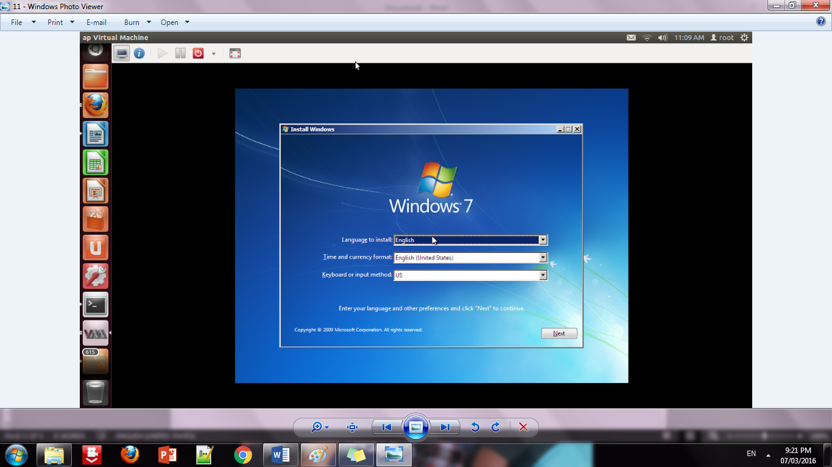

Step 10: Initialization of windows on virtual machine

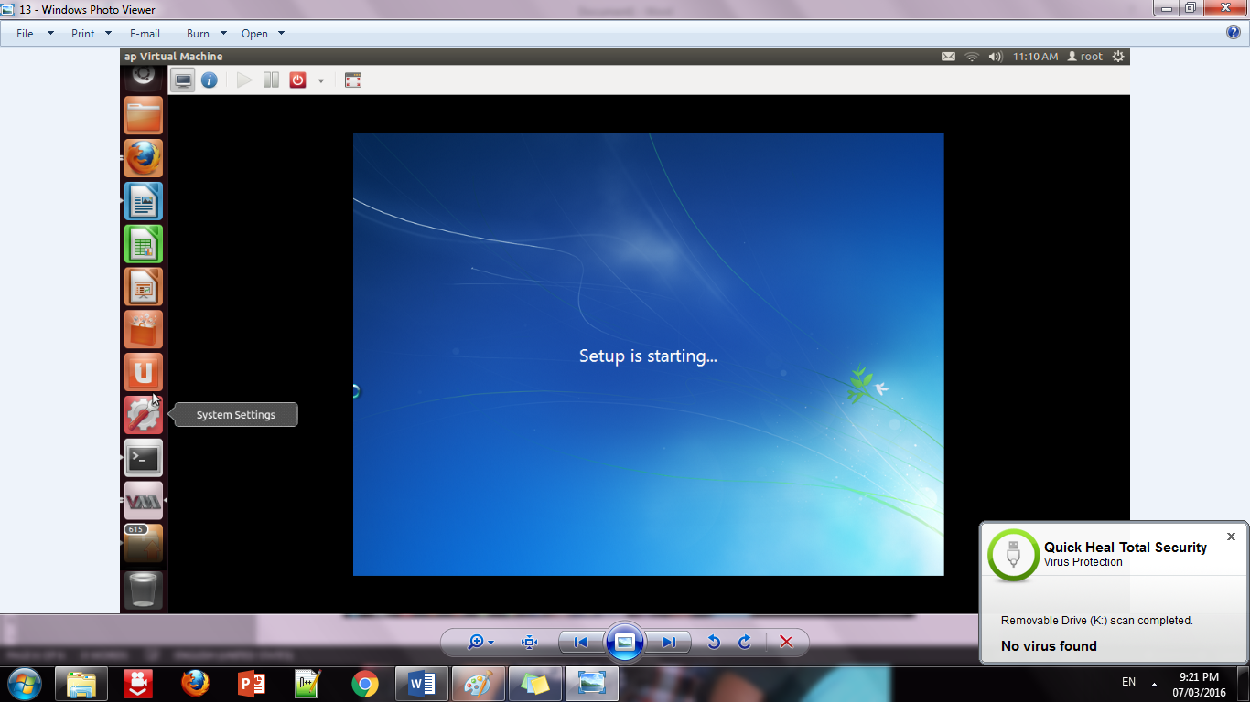

1. **Conclusion:**

Installation and configuration of KVM have been done successfully onto Ubuntu and users added. Like this we can create as many virtual machines as possible on OS and can install any windows onto it.

**Practical-6**

**Develop application to download image/video from server or upload image/video to server using MTOM techniques**

MTOMClient Index.jsp

<%@page import="java.io.BufferedOutputStream">

<%@page import="java.io.FileOutputStream">

<%@page import="java.io.FileInputStream">

<%@page import="java.io.BufferedInputStream">

<%@page import="javax.imageio.stream.FileImageInputStream">

<%@page import="java.io.File">

<%@page import="javax.xml.ws.soap.MTOMFeature">

<%@page contentType="text/html" pageEncoding="UTF-8">

<!DOCTYPE html>

<html>

<head>

<meta http-equiv="Content-Type" content="text/html; charset=UTF-8">

<title>JSP Page</title>

</head>

<body>

<%-- start web service invocation --><hr/>

<%

try {

pkg.ImageWS_Service service = new pkg.ImageWS_Service(); pkg.ImageWS port = service.getImageWSPort(new MTOMFeature(60000));

// TODO initialize WS operation arguments here String filePath="c:/msc/ABC.jpg";

File file=new File(filePath);

FileInputStream fis=new FileInputStream(file); BufferedInputStream bis=new BufferedInputStream(fis); java.lang.String filename = file.getName(); byte[]imageBytes=new byte[(int)file.length()]; bis.read(imageBytes);

port.upload(filename, imageBytes); bis.close();

out.println("File uploaded :"+filePath);

} catch (Exception ex) {

// TODO handle custom exceptions here

}

>

<%-- end web service invocation --><hr/>

<%-- start web service invocation --><hr/>

<%

try {

pkg.ImageWS_Service service = new pkg.ImageWS_Service(); pkg.ImageWS port = service.getImageWSPort();

// TODO initialize WS operation arguments here java.lang.String filename = "ABC.jpg";

String filePath="c:/msc/download/"+filename;

// TODO process result here

byte[] fileBytes = port.download(filename);

out.println("File downloaded"+filePath);

} catch (Exception ex) {

// TODO handle custom exceptions here

}

>

<%-- end web service invocation --><hr/>

</body>

</html> MTOMServer ImageWS.java package mypkg; import java.io.*;

import javax.jws.Oneway; import javax.jws.WebService; import javax.jws.WebMethod; import javax.jws.WebParam;

import javax.xml.ws.soap.MTOM; @MTOM(enabled=true,threshold=60000) @WebService(serviceName = "ImageWS") public class ImageWS { @WebMethod(operationName = "upload") @Oneway

public void upload(@WebParam(name = "Filename") String Filename, @WebParam(name = "ImageBytes") byte[] ImageBytes){

String filePath="C:/MSC/upload/"+Filename; try

{

FileOutputStream fos=new FileOutputStream(filePath); BufferedOutputStream bos=new BufferedOutputStream(fos); bos.write(ImageBytes);

bos.close();

System.out.println("Recieved file :"+filePath);

}

catch(Exception ex)

{

System.out.println(ex);

}

}

@WebMethod(operationName = "download")

public byte[] download(@WebParam(name = "Filename") String Filename) { String filePath="C:/MSC/upload/"+Filename;

System.out.println("Sending file :"+filePath); try

{

File file=new File(filePath);

FileInputStream fis=new FileInputStream(file); BufferedInputStream bis=new BufferedInputStream(fis); byte[] fileBytes=new byte[(int)file.length()]; bis.read(fileBytes);

bis.close(); return fileBytes;

}

catch(Exception ex)

**Practical-07**

**Implement FOSS-Cloud Functionality VSI (Virtual Server Infrastructure) Infrastructure as a Service (IaaS), Creating Virtual Machine or Storage**

**FOSS Cloud Installation:**

Steps:

1. Choose your keymap.
2. Confirm that you want to start: yes
3. Choose Demo-System: 1
4. Choose a Block-Device: sda
5. Confirm that you want to continue: yes
6. Confirm that you want to continue: yes
7. Choose the network interface: eth0
8. Choose if you want to use automatic network configuration: Yes
9. Reboot your system: yes
10. Login as root and run "fc-node-configuration -n demo-system --password admin"

Login as admin Password : admin

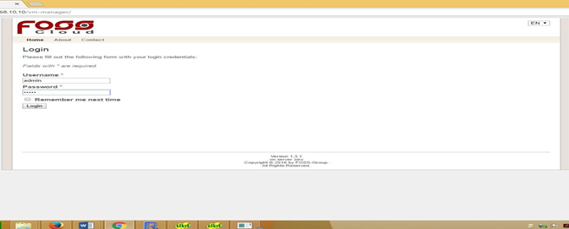

**Home page of FOSS Cloud at Client**

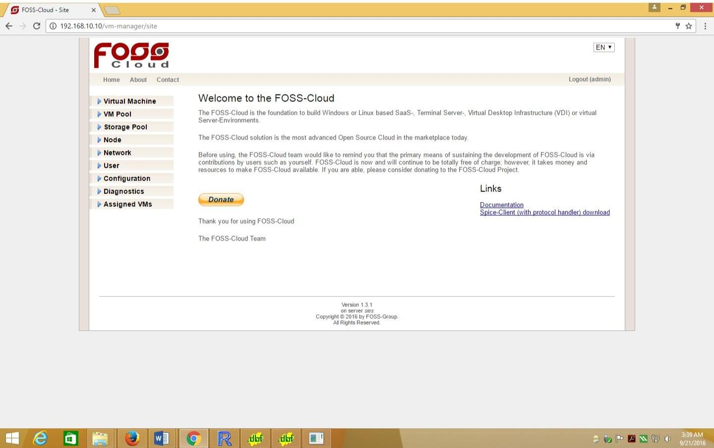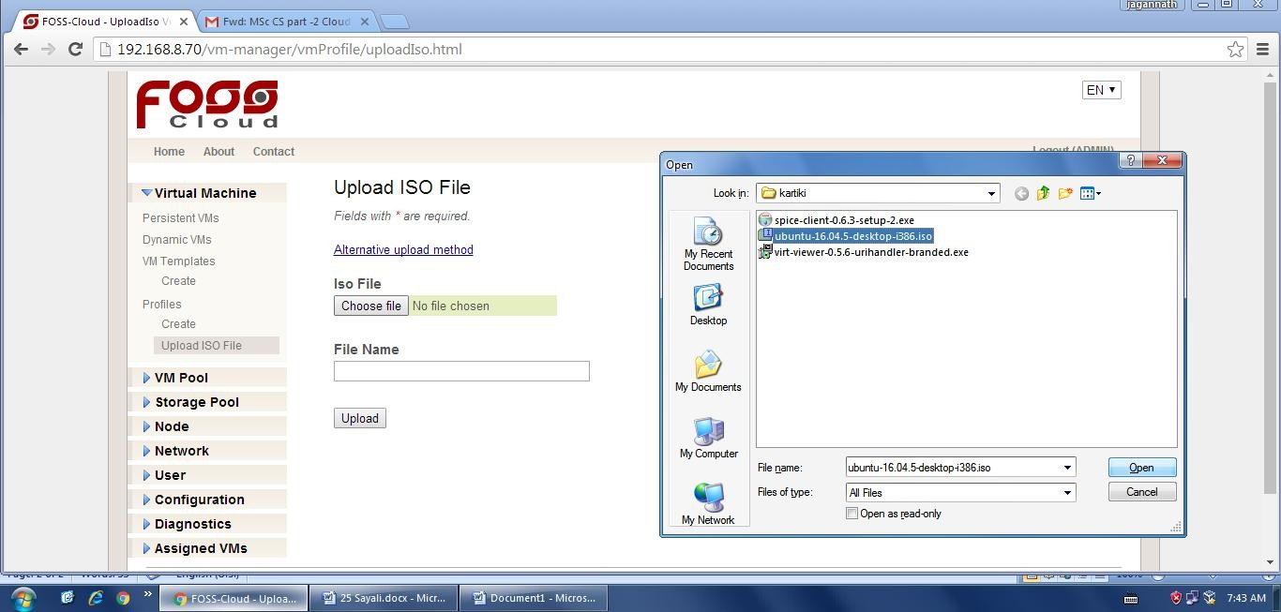

**Uploading ISO files to foss cloud**

* Go to virtual machine→Profile→Upload ISO file→file name.

**Creating a Profile**

The profile creates the relationship between the ISO file and the FOSS-Cloud.

1. Open Virtual Machines
2. Choose vm-Profiles
3. Choose the right Base Profile
4. Choose the right architecture (Windows only x86_64)
5. Chose the language (it is a information - not keyboard relevant)
6. Choose the ISO file
7. Fill out name and description
8. Choose the amount of memory and volume capacity
9. Choose amount of CPU
10. Choose clock offset (normally Windows is "localtime" and Linux is "utc")

**Creating Template**

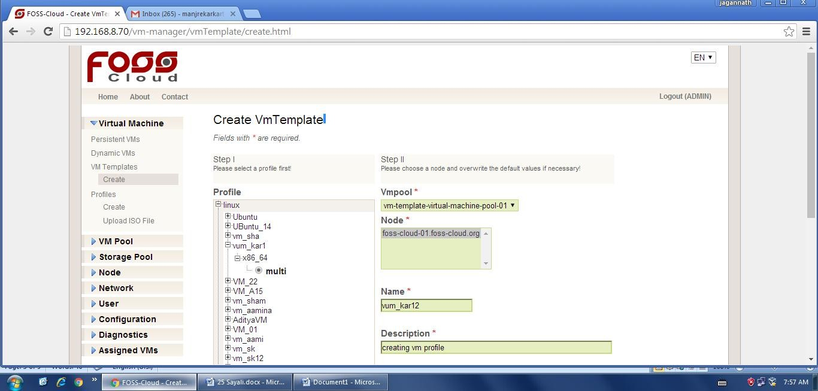

1. Choose the profile you have prepared before
2. Add the vm-pool and one or more nodes, where you will run this vm (when the chosen vm-pool has only one node assigned, you don't have a choice)
3. You can change all the other informations you have entered before

Click on "create" and the template is ready for installing the guest operating system.

* **Install virt Viewer and spice**

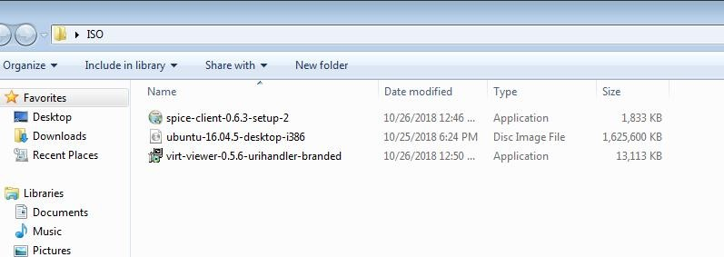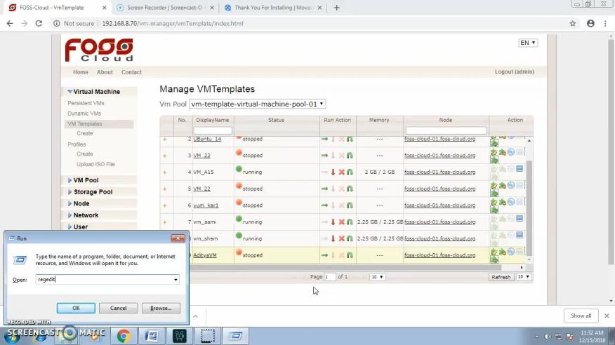

* **Go to regedit**
* **Go to**

**Computer** → **HKEY_CLASSES_ROOT** → **SPICE** → **SHELL** → **COMMAND**

* **Go to Default and click Modify**

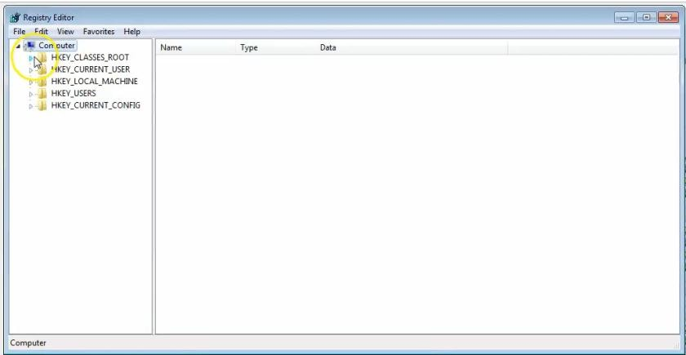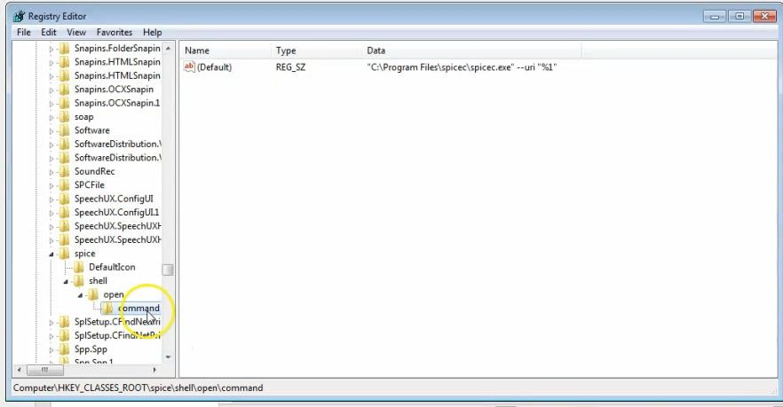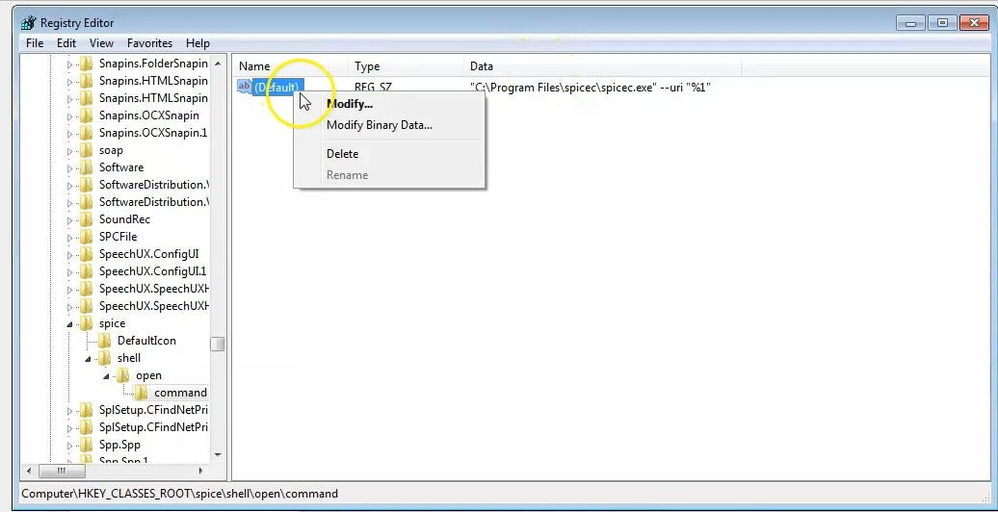

* **Paste path of virt viewer**→ **virt_viewer_path %1 (Actual path of Virt Viewer)**
* **Run Your VM and View using VM Template.**

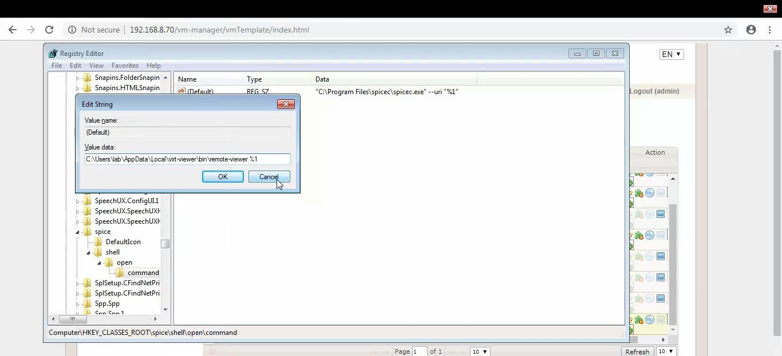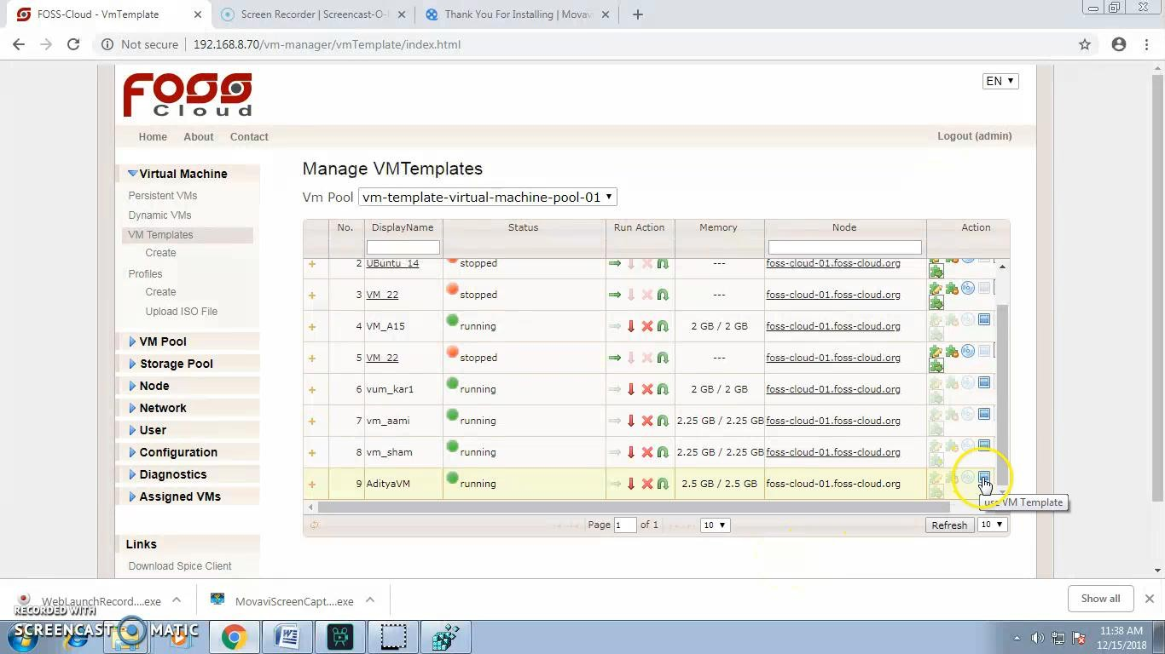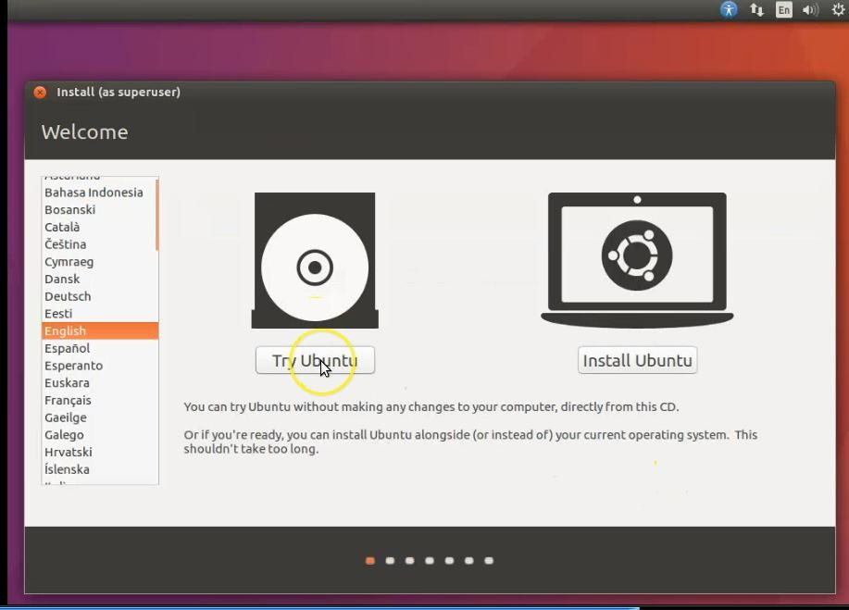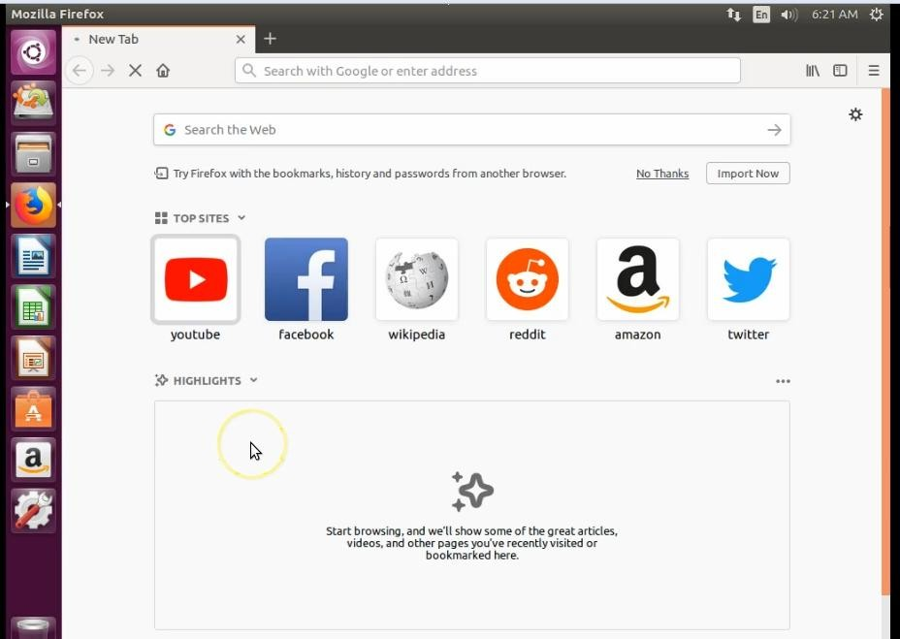

* **Open Browser in Ubuntu.**

**Practical-08**

**I Implementation of Openstack with user and private network creation.**

**Installation of OpenStack**

In order to install the DevStack in a system, first, you have to create a Linux VM on your computer (such as using VirtualBox or VMware) or remotely in the cloud (such as using AWS).

The VM must have at least 4GB of memory, and the proper internet connection is also important. Here, we are going to use one version of the ubuntu, i.e., 18.04.

Follow the following steps to install the OpenStack in your ubuntu virtual machine :

**Step 1: Update Ubuntu System**

Open the terminal and run the following command to ensure that the system is up to date :

1. $ sudo apt update
2. $ sudo apt -y upgrade
3. $ sudo apt -y dist-upgrade

Reboot the system after running the above command. To reboot the system, run the following command $ sudo reboot

**Step 2: Create Stack User**

It is important that the devstack must run as a regular user (non-root user) with the sudo enabled.

To keep this note in mind, let's create a new user with the name "stack" and assign the sudo permissions or privileges. To create a stack user, run the following command in your terminal:

$ sudo useradd -s /bin/bash -d /opt/stack -m stack

Now, to assign the sudo privileges to the stack user, run the following command :

$ echo "stack ALL=(ALL) NOPASSWD: ALL" | sudo tee /etc/sudoers.d/stack

**Install the Git**

In Most of the ubuntu systems, git comes by default. But if git is missing on your system, then install it by running the following command:

1. $ sudo apt install git -y

**Step 4: Download OpenStack**

Once you install the git, use the git command to download the DevStack from Github.

1. $ git clone https://git.openstack.org/openstack-dev/devstack

**Step 5: Create a DevStack Configuration File**

First of all, go to the devstack directory by running the following command :

1. $ cd devstack

Now, create a local.conf file in which you have to enter the four passwords and the host IP address

**Output :**

